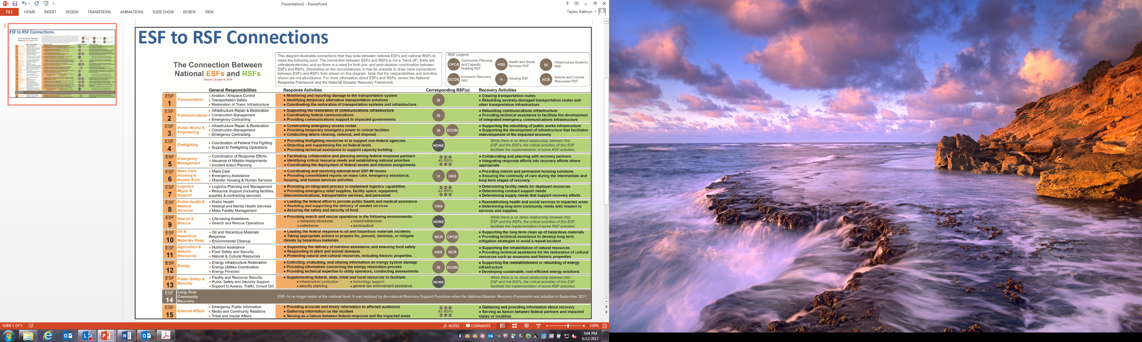

Photo Credit to FEMA Region III All Hazards Plan