Please rsvp & sign in at the meeting for both days.
Your hosts: Susan Krala, Susan.E.Krala@uscg.mil, (510) 437-2794
Lance Richman, Richman.Lance@epa.gov, (415) 972-3022
Attire
- Military: Tropical Dress Blue, Operational Dress Uniform (ODU) or Battle Dress Uniform (BDU).
- Civilian: Business casual.
Directions:
See the map on the last page of this agenda.
- From I-80 from Sacramento or San Francisco, take EXIT 70 to CA-113 N toward Woodland.
- Continue 1.43 miles to EXIT 27 Hutchison Drive toward UC Davis.
- Use the map on the last page to get from Hutchison Drive to UC Davis and Gladys Valley Hall.
- If you’re using a GPS device, go to: 1089 Garrod Drive, Davis, CA 95616. It takes you to Visitor Parking lot 50. The map on the last page of this agenda shows Gladys Valley Hall.
- Buy a parking permit at the permit machine. Cost is $9/day.
Local Dining info:
See the list and map on pages 2 and 3.
Speakers:
Please send your slide show to Toy.Arthur@epa.gov at least one day before the meeting.
Conference Call & WEBINAR:
- Connect via Adobe Connect at https://epawebconferencing.acms.com/lrichman/
- Login by typing your email address.
- Please mute your microphone.
- To listen via Adobe you only need the speakers on your computer.
To speak, you need a headphone with a microphone.
Agenda, Hotels & Future Meetings:
The RRT web site has moved to a new host and is under construction. The URL remains http://www.rrt9.org.
Lunch Places
ASUCD Coffee House Coho & Deli  1 Shields Ave, Davis, CA 95616  (530) 752-6622  Segundo Dining Commons  1 Shields Ave, Davis, CA 95616  (530) 752-0135  BioBrew by CoHo  1 Shields Ave, Davis, CA 95616  (530) 752-3075  Gunrock Pub  1 Shields Ave, Davis, CA 95616  (530) 752-6262  La Crepe  1 Shields Ave, Davis, CA 95616  (530) 752-7057  Sage Street Bistro  201 Sage St, Davis, CA 95616  (530) 231-5550  Hub Café  201 Sage St, Davis, CA 95616  (530) 752-9937  Brick Toast Café  201 Sage St, Davis, CA 95616  (530) 231-5550  Raja Indian Cuisine  207 3rd St, Davis, CA 95616  (530) 753-9664 | Namaste Nepal  825 Russell Blvd #30, Davis, CA 95616  (530) 792-7321  Starbucks Coffee  825 Russell Blvd, Davis, CA 95616  (530) 753-2686  Ohana Hawaiian BBQ  825 Russell Blvd, Davis, CA 95616  (530) 750-1888  The Graduate  805 Russell Blvd, Davis, CA 95616  (530) 758-4723  Fluffy Donuts & Sandwich  757 Russell Blvd, Davis, CA 95616  (530) 756-2037  Subway  757 Russell Blvd, Davis, CA 95616  (530) 753-3223  Lees Deli  737 Russell Blvd, Davis, CA 95616  (530) 750-0737  Chengdu Style  737 Russell Blvd, Davis, CA 95616  (530) 746-2272

Lunch Map
https://www.mapquest.com/search/results?layer=restaurants&query=1089%20Garrod%20Drive,%20Davis,%20CA%2095616&boundingBox=47.12995075666307,-121.11328124999998,28.729130483430154,-74.8828125&page=0
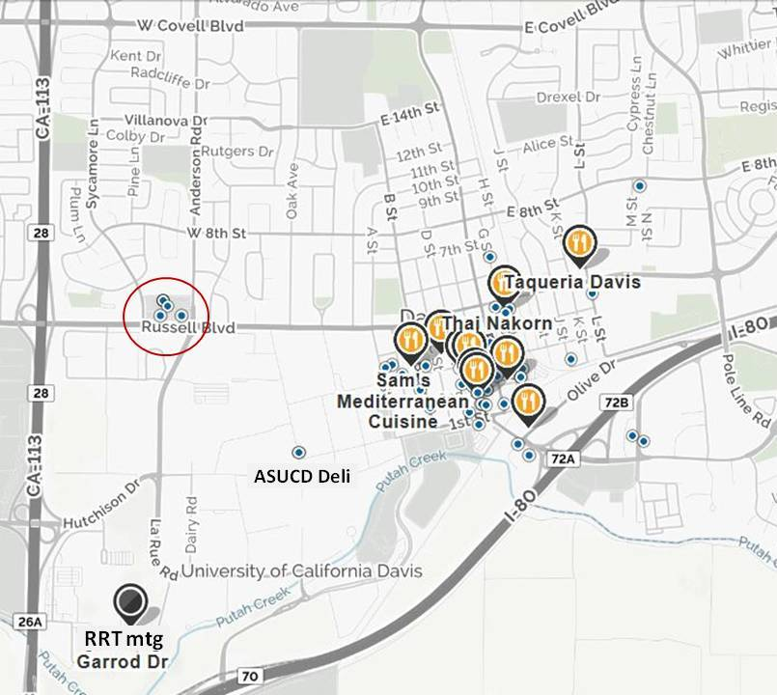
Tuesday, July 11th 2017, 0900-1600
Time | Topic | Speaker
0900  (3 min) | Safety & comfort. | Ms. Susan Krala, RRT IX Coordinator, USCG District 11, susan.e.krala@uscg.mil
0903  (7 min) | Welcome. | - Mr. Dan Meer, RRT IX Co-Chair,  US EPA, Region IX, meer.daniel@epa.gov  - Mr. Tim Holmes, RRT IX Co-Chair, USCG District 11, timothy.p.holmes@uscg.mil  - CAPT Anthony Ceraolo, Commander, USCG Sector San Francisco, anthony.j.ceraolo@uscg.mil
0910  (5 min) | Agency Representative self-introductions. | Ms. Susan Krala, USCG
0915  (20 min) | Agency Updates, State  - AZ Dept. of Environmental Quality  - CA EPA: Interagency Refinery Task Force  - CA Governor’s Office of Emergency Services  - CA Office of Spill Prev. & Response  - CA Coastal Commission  - NV Department of Public Safety | - Ms. Yvonne Rodriguez (0 min)  - Mr. Paul Penn (5 min)  - Mr. Trevor Anderson (0 min)  - CAPT Tom Cullen (10 min)  - Mr. Jonathan Bishop (5 min)  - Mr. Caleb Cage (0 min)
0935  (45 min) | Environmental Protection Agency Updates | Tom Dunkelman, EPA IX, On-Scene Coordinator, Dunkelman.Tom@epa.gov

Tuesday, July 11th 2017, 0900-1600
Time | Topic | Speaker
1020 | Break/Networking (10 minutes)
1030  (30 min) | Booming with Drones | Mr. John Bradley, Founder, H2O Environmental, Inc., 702-985-7641, john@envcleanup.com
1100  (30 min) | Overview of the National Response Team | Ms. Monica Rusk, USCG NRT Coordinator, Monica.K.Rusk@uscg.mil
1130  (30 min) | Rapid Containment and Recovery  in Slow and Fast Water Conditions | Mr. Bob Chickering, AirTech Foam,  cdmchick@aol.com
1200 | Lunch Break/Networking (75 minutes) | See map on pgs 2 & 3 for dining options.

Tuesday, July 11th 2017, 0900-1600
Time | Topic | Speaker
1315  (25 min) | Agency Updates: Federal | * Dark font denotes agency rep will present.
 | - Department of Agriculture (USDA, USFS)  - Animal Plant Health Inspection Service (APHIS)  - Department of the Army, Corps of Engineers (ACE)  - Department of Commerce (DOC, NOAA, NMFS)  - National Weather Service  - Department of Defense (DOD, NORTHCOM)  - Defense Coordinating Officer (DCO)  - Department of Energy (DOE)  - Department of Health & Human Svs (CDC, ATSDR)  - Department of Homeland Security (DHS, FEMA)  - Department of the Interior (DOI OEPC)  - Bureau of Land Management (BLM)  - Bureau of Safety & Environmental Enforcement  - Bureau of Reclamation (BR)  - Fish & Wildlife Service (FWS)  - Department of Justice (DOJ)  - Department of Labor (DOL, OSHA)  - Department of State (DOS)  - Department of Transportation (DOT)  - Federal Railroad Administration (FRA)  - Pipeline HazMat Safety Administration (PHMSA)  - General Services Administration (GSA)  - Nuclear Regulatory Commission (NRC) | - Ms. Belinda Walker (5 min)  - Mr. Todd Smith (0 min)  - Mr. Kelley Aasen (0 min)  - Mr. Jordan Stout (5 min)  - Mr. Scott Carpenter (0 min)  - Mr. Stuart Morgan (0 min)  - LTC Jerry Brown (0 min)  - Ms. Sarah Hartson (0 min)  - Ms. Libby Vianu (0 min)  - Mr. John Woytak (0 min)  - Ms. Janet Whitlock (10 min)  - Mr. James Weigand (0 min)  - Mr. Jason Langteau (0 min)  - Mr. Jeffery Smith (0 min)  - Mr. Damian Higgins (0 min)  - Mr. Mike Underhill (0 min)  - Mr. Paul Leary (0 min)  - Ms. Rona Rathod (0 min)  - Mr. Earl Whitley (0 min)  - Mr. Ernie Sirotek (0 min)  - David Mulligan (5 min)  - Ms. Catherine Looper (0 min)  - Ms. Linda Howell (0 min)
1340  (35 min) | U.S. Coast Guard Updates:  - 11th District Response Advisory Team (DRAT)  - Incident Management Assist Team (IMAT)  - National Strike Force Coordination Center  - Pacific Strike Team | - LCDR Kristin Driscoll (5 min)  - LCDR Max Seda (15 min)  - MST1 Audrey Gurganus (0 min)  - Mr. Jim Pitkin &  MST1 Charles Varela (15 min)
1415 | Break/Networking (10 min)

Tuesday, July 11th 2017, 0900-1600
Time | Topic | Speaker
1425  (45 Min) | U.S. Coast Guard Updates:  - Sector San Francisco  - Sector San LA/LB  - Sector San Diego | Continued…  - MST2 Scott Wingfield, USCG and  MST3 Anton Marc, USCG (20 min)  - Mr. Robert Willoughby, USCG (10 min)  - LT Denny Ernster, USCG (15 min)
1510  (35 min) | Lifelines: Infrastructure/ESF Group Construct Implemented During the February 2017 Statewide Storms Incident in California. | Mr. Chris Reidel, Protective Security Advisor,  US DHS, Office of Infrastructure Protection, Sacramento District, 207-400-2769  christopher.reidel@hq.dhs.gov
1545  (15 min) | USCG & the National Disaster Recovery Framework (NDRF) | Mr. Tim Holmes, USCG District 11,  Incident Mgmt Preparedness Advisor, timothy.p.holmes@uscg.mil
1600 | Adjourn for today. | RRT IX Co-Chairs
Wednesday, July 12th 2017, 0900-1610
Time | Topic | Speaker
0900  (3 min) | Safety & comfort. | Ms. Susan Krala  RRT IX Coordinator USCG District 11.
0903  (7 min) | Welcome. | - Mr. Dan Meer, RRT IX Co-Chair, US EPA, Region IX  - Mr. Tim Holmes, RRT IX Co-Chair, USCG District 11
0910  (5 min) | RRT Member Agency Representatives  and Attendees Self Introductions. | Ms. Susan Krala, USCG District 11
0915  (60 min) | The Oroville Dam Incident: February 2017. | Ms. Christy A. Jones, P.E., Acting Deputy Director Security and Emergency Management Program, CA Department of Water Resources Christy.Jones@water.ca.gov
1015 | Break/Networking (10 min)
1025  (60 min) | Statewide Flood Operations:  California’s 2016-2017 Flood Season | Ms. Delia McGrath, P.E., Senior Engineer,  Chief, Response & Security Section,  Division of Flood Management,  CA Department of Water Resources, Delia.Mcgrath@water.ca.gov
1125  (40 min) | FEMA Incident Management Assist Team (IMAT) | Mr. Scott Schaefer, FEMA, Operations Section Chief, National IMAT-West, scott.schaefer@fema.dhs.gov
1205 | Lunch/Networking (60 minutes) | See map on pgs 2 & 3 for dining options.

Wednesday, July 12th 2017, 0900-1610
Time | Topic | Speaker
1305  (25 min) | NOAA/NWS: Region IX Hurricane Season Outlook / Fire Season / ‘Drought’ Status | Mr. Scott Carpenter, NOAA/NWS,  Regional Response and Preparedness Specialist, scott.carpenter@noaa.gov
1330  (45 min) | Federally Recognized Tribes: Requesting a Federal Disaster Declaration from the President. | Mr. Randy Brawley, FEMA,  Preparedness Analysis Branch Chief, randy.brawley@fema.dhs.gov
1415  (45 min) | California Disaster Assistance Act (CDAA): Accessing State/Federal support following a declared disaster. | Mr. Sean Smith, CA OES, Disaster Program Specialist, (916) 845-8238,  sean.smith@caloes.ca.gov
1500 | Break/Networking (10 min)
1510  (20 min) | National Recovery Framework:  Recovery Integration During  Response | Mr. Robert Troy, FEMA Region IX, Federal Disaster Recovery Coordinator, robert.troy@fema.dhs.gov
1530  (40 min) | Recovery Best Practices:  Floods, REP exercises, and oil spills. | Mr. Robert Troy, FEMA Region IX
1610 | Thank you UC Davis for use of your facility!  Meeting Adjourn. | RRT IX Co-Chairs

