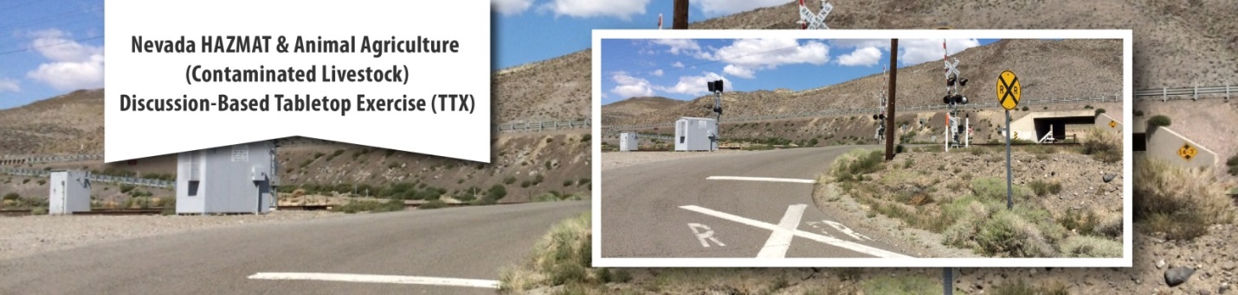
AFTER ACTION REPORT

Thursday, November 6, 2014
Washoe County Regional Emergency Response Operation Center
5195 Spectrum Blvd., Reno, Nevada 89512
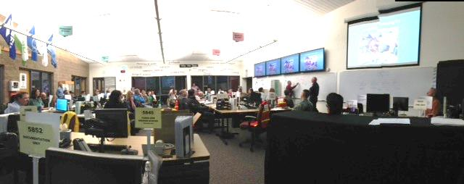
 |  |  | 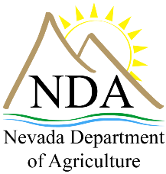 | 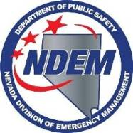 | 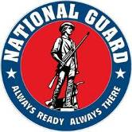

THIS PAGE LEFT BLANK INTENTIONALLY

Handling Instructions
The formal title of this document is “Nevada Hazmat Animal-Agriculture (Contaminated Livestock) Discussion-Based Tabletop Exercise, After Action Report.”
Points of Contact:
Contact Name: Lance Richman
Name of Agency: US EPA
Address: 75 Hawthorne Street, SFD 9-3
City/State/Zip: San Francisco, CA 94105
Phone and Extension: (415) 972-3022
Email Address: Richman.Lance@epa.gov

Contact Name: Todd Smith
Name of Agency: USDA/APHIS
Address: 160 Foss Creek Circle, #1172
City/State/Zip: Healdsburg, CA 95448
Phone and Extension: (707) 431-1847
Email Address: Todd.L.Smith@aphis.usda.gov

THIS PAGE LEFT BLANK Intentionally

Executive Summary
The Nevada Hazmat Animal-Agriculture (Contaminated Livestock) Discussion-Based Tabletop Exercise was designed to coordinate and build relationships between local, state, federal response agencies and local, state, federal agricultural/veterinary agencies/individuals in the Washoe County community, and to test these two community’s ability to respond to an environmental spill that has impacted livestock and the Truckee River. The exercise was also an excellent opportunity for the response community and the agricultural community to learn how the two communities operate and need to develop a better communication system. The planning team was composed of agencies with diverse expertise, including state partners from Nevada Department of Agriculture (NDA), the Nevada National Guard (NNG), Nevada Division of Emergency Management (NDEM) and federal agencies including the Environmental Protection Agency (EPA), the United States Department of Agriculture Veterinary Service (USDA/VS), and the United States Department of Agriculture Animal Plant Health Inspection Service (USDA/APHIS).
To prepare the players for the exercise three brief trainings were presented at the beginning of the day. Steve Calanog, EPA Federal On-Scene Coordinator (FOSC) presented a brief overview of the Incident Command System (ICS), Todd Smith, USDA/APHIS presented information on the Food Safety and Security Act, Sargent First Class (SFC) Mike Connell, NNG presented a brief on Emergency Responses to an Incidents Involving Large Livestock in Nevada, and Dr. Greenlee, Nevada State Veterinarian presented a brief “Livestock from Pasture to Table”. Additionally, Jason Suckow, APHIS/WS presented information on APHIS/Wildlife Services resource capabilities and the MOU with EPA/USCG.
Based on the planning teams deliberations the following objectives were identified by the Exercise Design Team to be tested in the tabletop exercise:
- Establishing an Incident Command System (ICS) response organization and an ICS 207 Org Chart.
- Prepare an Incident Objectives (ICS202) and an Incident Notification list/flowchart (during both normal business and after business hours).
- Identify response and transportation resources and protocols for animal response activities (e.g., Livestock Response Task Force Team deployment, etc.) consistent with Draft State Animal/Ag Response Plan
- Identify the responsible agency(s), contractor support, approved disposal methods, and approved sites for decontamination and disposal of carcasses consistent with new EPA/USCG/USDA MOU [Wildlife Response Activities during Oil or Hazardous Substance Pollution Incidents].
- Identify and Develop a Strategy to address contamination risk to other livestock/animals not directly impacted by incident (e.g., surrounding ranches, feedlot, wildlife, etc.).

The purpose of this report is to analyze exercise results, identify strengths to be maintained and built upon, identify potential areas for further improvement, and support development of corrective actions.

MAJOR STRENGTHS
The major strengths identified during this exercise are as follows:
- Engagement by Local, State, Federal Responders and Local, State, Federal agricultural/veterinary agencies/individuals Partners. The exercise demonstrated that the response and veterinary community are interested in seeking collaborative solutions to enhancing the ability to respond to a hazardous materials incident that may involve livestock/agriculture. Key partners at all levels of government and the veterinary community actively participated and contributed to the success of the exercise.
- Feedback for Improvement of Plans. Exercise participants applied the discussion of how the response would play out to inform future updates to federal, state and local response plans. This exercise demonstrated the need to develop new plans and procedures for responses that involve hazmat and livestock. Through strengthening of relationships and increasing awareness of response authorities, additional exercises will lead to greater coordination for the response and veterinary community.
PRIMARY AREAS FOR IMPROVEMENT
Throughout the exercise, several opportunities to improve communication and coordination between the emergency response and veterinary community to a hazardous materials spill were identified. The primary areas for improvement, including recommendations, are as follows:
- Expand Exercise Participation. There were some key stakeholders absent from the exercise that should be included in future events. In particular, highway patrol, railroads, water board, fish and wildlife service, law enforcement, and private sector partners should be invited to participate and ensure that partners from these disciplines at all levels of government are included.
- Response Plans. Response plans for the area need to be identified, developed and exercised. The Truckee River Geographic Response Plan should have been utilized during the exercise.
- Clarification of Jurisdictional Authorities. The exercise clearly illustrated the need for the emergency response community and the veterinary community to exercise and train together so they can learn the jurisdictional authorities, resources, responsibilities and response capabilities of each other’s organizations.
As with all exercises the work done here should be built upon in future training and exercises. Drawing on the information presented in this report, emergency response planners and veterinary responders in the community should conduct additional discussion-based and operational exercises focusing on the objectives and the recommendations presented in the improvement plan attached to this report.
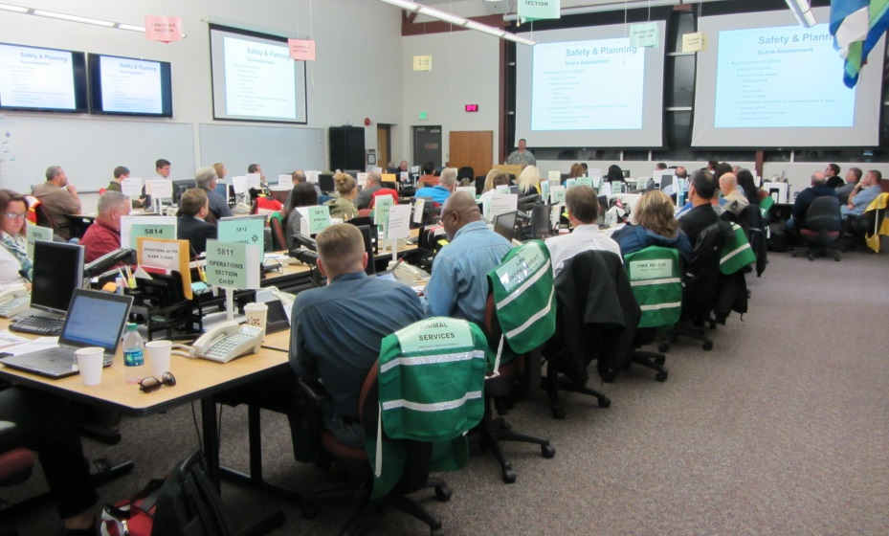
Caption: SFC Mike Connell (Nevada National Guard) presented a training brief on emergency response to an incident involving livestock in Nevada.

THIS PAGE LEFT BLANK Intentionally

TABLE OF CONTENTS
TABLE OF CONTENTS 1
EXERCISE OVERVIEW 3
EXERCISE DESIGN SUMMARY 3
ACKNOWLEDGEMENTS 3
PARTICIPATING ORGANIZATIONS 4
NUMBER OF PARTICIPANTS 4
EXERCISE OBJECTIVES AND CAPABILITIES 7
GOALS 7
CAPABILITIES TO BE TESTED 7
SCENARIO SUMMARY 9
INCIDENT CONTROLS 10
SITE MAP 11
EXERCISE ANALYSIS 13
GENERAL 13
MODULE 1 AND 2: PROPOSED QUESTIONS 14
OBJECTIVE 1 15
OBJECTIVE 2 16
OBJECTIVE 3 18
OBJECTIVE 4 19
OBJECTIVE 5 19
CONCLUSION 21
ATTACHMENT A LIST OF ACRONYMS 23
ATTACHMENT B EXERCISE FEEDBACK SUMMARY 25
ATTACHMENT C IMPROVEMENT PLAN 27

THIS PAGE LEFT BLANK INTENTIONALLY

EXERCISE OVERVIEW

EXERCISE DESIGN SUMMARY
Exercise Name: Nevada Hazmat Animal-Agriculture (Contaminated Livestock) Discussion-Based Tabletop Exercise
Type of Exercise: Discussion-Based Tabletop Exercise
Date: Thursday, November 6, 2014
Duration: 0700– 1530 Hours
Location: Washoe County Regional Emergency Response Operation Center
5195 Spectrum Blvd.,
Reno, Nevada 89512
Sponsors:

- Regional Response Team (RRT) 9, USDA – APHIS (ESF 11), USEPA, Nevada Department of Agriculture, Nevada Division of Environmental Management and the Nevada National Guard.
Scenario Type: Livestock Tractor-Trailer/Train Accident Hazardous Materials Release: Bakken Crude Oil with Oil Contaminated Livestock.
Core Capabilities Tested:
- Common: Operational Coordination
- Response: Situational Assessment , Environmental Response/Health and Safety, On-scene Security and Protection, Critical Transportation, Livestock Fatality Management

ACKNOWLEDGEMENTS
Exercise Design Team:

- Steve Calanog, USEPA
- Tim Cary, NDEM
- Mike Connell, NNG
- Tom Dunkelman, USEPA
- Dr. Keith Forbes, NDA
- Dr. Lee R. Hall, USDA/ APHIS/VS
- Dr. Greg Ramos, USDA/APHIS/VS
- Lance Richman, US EPA/RRT 9
- Todd Smith, USDA/APHIS

Facilitator: Dr. Scott Beutelschies, USDA/VS

Exercise Funding Provided by: US EPA

Contract Support provided by: Ecology and Environment, Inc. (E & E)

Exercise Venue provided by: Washoe County

PARTICIPATING ORGANIZATIONS

FEDERAL
- DOI - Bureau of Land Management
- Federal Emergency Management Agency – Region 9
- NOAA
- United States Coast Guard
- United States Department of Agriculture, Forest Service
- USDA/APHIS/MRPBS ESF 11
- USDA/APHIS/IES
- USDA/APHIS/VS
- USDA/APHIS/WS
- USDA/FSIS/OIEA/CID
- United States Coast Guard
- United States Department of Agriculture, Forest Service
- United States Environmental Protection Agency
- United States Environmental Protection Agency-Environmental Response Team
OTHER GROUPS
- California Farm Bureau Federation
- Private Veterinarians
- Reno Rendering
LOCAL
- Carson City Fire Department/Emergency Management
- North Lyon County Fire Protection District Pershing County Office of Emergency Management
- Storey County Office of Emergency Management
- Washoe County- Regional Animal Services
STATE
- California Department of Agriculture
- California Office of Emergency Services
- Nevada Department of Agriculture
- Nevada Department of Agriculture, Animal Disease Laboratory
- Nevada Department of Agriculture, Animal Industries Division
- Nevada Department of Transportation
- Nevada Division of Emergency Management
- Nevada Division of Emergency Management-Homeland Security
- Nevada National Guard
- Nevada State Veterinarian
- State Attorney General’s Office

NUMBER OF PARTICIPANTS
- Players: 54
- Observers: 1
- Facilitators: 1
- Exercise Support: 3
- TOTAL: 59
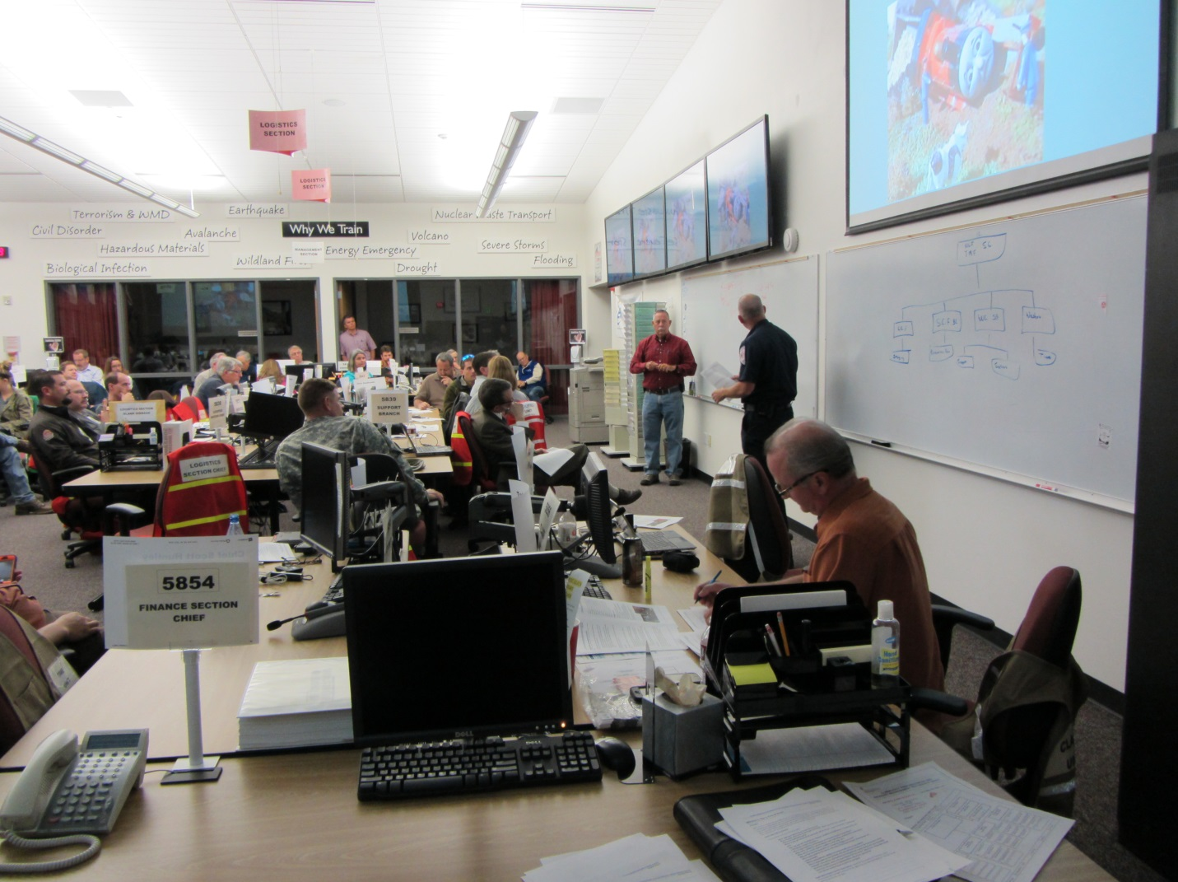
Caption: Exercise participants Joe Curtis, Storey County Emergency Management and Scott Huntley, North Lyon County Fire are drafting the ICS 207 organization chart for Module 1.

THIS PAGE LEFT BLANK INTENTIONALLY

EXERCISE OBJECTIVES AND CAPABILITIES
GOALS
The goals of this exercise are to improve hazardous materials emergency response coordination to a railcar versus tractor-trailer carrying livestock incidents by:
- Increasing NIMS-based multi-agency coordination capabilities pertaining to combined animal and HAZMAT issues in order to more effectively support emergency response at the Local, State, Tribal (potentially), and National levels.
- Providing participants an opportunity to evaluate current response concepts, plans, and capabilities for a response to a livestock/HAZMAT incident and to identify and verify responsible agencies involved in a livestock/HAZMAT incident, strengths to build upon and areas to improve.

Exercise design, conduct, and improvement planning will be conducted in a manner consistent with the Homeland Security Exercise Evaluation Program (HSEEP).

SMART OBJECTIVES
The following objectives were identified by the Exercise Design Team to be tested in the tabletop exercise:
- Establishing an Incident Command System (ICS) response organization and an ICS 207 Org Chart.
- Prepare an Incident Objectives (ICS202) and an Incident Notification list/flowchart (during both normal business and after business hours).
- Identify response and transportation resources and protocols for animal response activities (e.g., Livestock Response Task Force Team deployment, etc.) consistent with Draft State Animal/Ag Response Plan
- Identify the responsible agency(s), contractor support, approved disposal methods, and approved sites for decontamination and disposal of carcasses consistent with new EPA/USCG/USDA MOU [Wildlife Response Activities during Oil or Hazardous Substance Pollution Incidents].
- Identify and Develop a Strategy to address contamination risk to other livestock/animals not directly impacted by incident (e.g., surrounding ranches, feedlot, wildlife, etc.).

CAPABILITIES TO BE TESTED
This exercise utilizes the Core Capabilities outlined in the National Preparedness Goal to serve as a basis for evaluating exercise play. The key Core Capabilities that will be tested are listed below. In recognition that the exercise will include partner public health agencies at the local and state level, the capabilities have been linked to the Centers for Disease Control and Prevention Public Health Preparedness Capabilities.

Common
- Operational Coordination. Establish and maintain a unified and coordinated operational structure and process that appropriately integrates all critical stakeholders and supports the execution of core capabilities.
  - Related Target Capabilities: Emergency Operations Center (EOC) Management, On-Site Incident Management
  - Related Public Health Capabilities: Emergency Operations Coordination
Response
- Situational Assessment. Provide all decision makers with pertinent information regarding the nature and extent of the hazard, any cascading effects, and the status of the response.
  - Related Target Capabilities: None
  - Related Public Health Capabilities: Information Sharing
- Environmental Response/Health and Safety. Ensure the availability of guidance and resources to address all hazards, including hazardous materials, acts of terrorism, and natural disasters in support of the responder operations and the affected communities.
  - Related Target Capabilities: Environmental Health, Responder Safety and Health, Weapons of Mass Destruction and Hazardous Materials Response and Decontamination
  - Related Public Health Capabilities: Responder Safety and Health
- On-Scene Security and Protection. Ensure a safe and secure environment through law enforcement and related security and protection operations for people and communities located within affected areas and also for all traditional and atypical response personnel engaged in lifesaving and life-sustaining operations.
  - Related Target Capabilities: Emergency Public Safety and Security Response
  - Related Public Health Capabilities: Emergency Public Safety and Incident Scene Control
- Critical Transportation. Provide transportation (including infrastructure access and accessible transportation services) for response priority objectives, including the evacuation of people and animals, and the delivery of vital response personnel, equipment, and services into the affected areas.
  - Related Target Capabilities: Citizen Evacuation and Shelter-in-Place
  - Related Public Health Capabilities: None
- Mass Care (Animal Component) Livestock Fatality Management. Provide life-sustaining services to the affected livestock with a focus on triage, decontamination, animal health and hazardous materials issues. Provide carcass fatality management services, including carcass recovery, identification, decontamination and disposal by working with State and Local authorities to also provide temporary carcass storage alternatives and permanent disposal solutions.
  - Related Target Capabilities: None
Related Public Health Capabilities: None

SCENARIO SUMMARY
At approximately 2300 hours, off Interstate-80 (I-80) at exit 40 (Painted Rock), two cattle hauling tractor trailers pulled off the highway. Both trailers were carrying 100 head of 900 lb. dairy steers and 15 head of dairy cows, and were en route to a feedlot west of Fallon, NV. The cows were destined for a local Fallon dairy. The planned route called for a rest stop further along the highway. After realizing the mistake, the drivers decided to turn around and continue on towards the intended destination further down the highway. They both crossed the railroad tracks running parallel to the interstate and along the Truckee River to turn around and get back on the interstate. Once across, one truck turned left and stopped about 20 yards past the railroad crossing. The second driver made a tight turn and was forced to back up in order to make the turn. The driver failed to notice the oncoming train. The train was moving east, strikes the cattle truck forcing it into the other stopped cattle truck causing both to turn over. The one cattle truck hit by the train is smashed open in the tail end and thrown into the other cattle truck turning it over and opening it as well through the roof.
SPECIAL CONSIDERATIONS/CONDITIONS
- The train is carrying Bakken crude oil in tanker cars.
- Three cars derail and overturn rupturing the tankers and spilling the crude oil which runs down into the Truckee River.
- Cattle are contaminated with oil. Some of the cattle are loose and some are injured and wandering around the crash scene.
- One of the truck drivers is killed upon impact, the other is wounded.
- Of the 100 steers and 15 dairy cows that were on the two trailers, 36 were killed, 24 were wounded, 25 are wandering loose in the vicinity and the remaining 30 cannot be located.
- Some of the cattle are identified as grossly contaminated with the spilled crude oil.
- A fire has erupted on the derailed tanker cars at the crash scene.

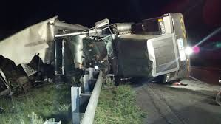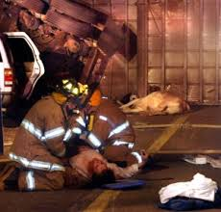

Incident Controls
IMMEDIATE ISSUES
- Scene Security
- Saving lives
- Fire
- Hazardous Materials
  - Containment
  - Spill control into the Truckee River
- Loose and injured animals (threat to traffic)
- Carcass Disposal
- Animal Triage
- Mass Euthanization and Removal of Contaminated Carcasses
- Locate Missing Cattle
- Animal Decontamination
- Withdrawal Times for Hydrocarbon Contamination
- Ingestion vs Dermal Contamination on Fur Bearing Mammals
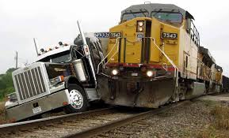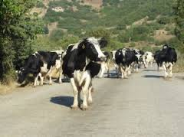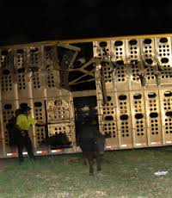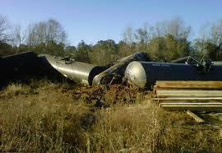

SITE MAP
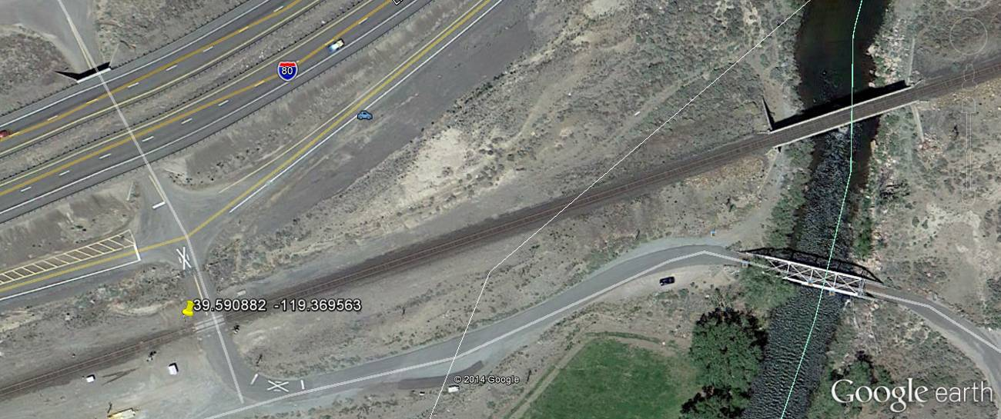
Caption: Site of the train vs. tractor trailer accident. Exit 40 (Painted Rock Exit) off of Interstate 80.

MODULE 1 – Day 1, First 24 Hours
After the train collides with the cattle truck, it is smashed open and thrown into a second cattle truck turning it over releasing the contents of the trailers which in this case are breeding steer and dairy cows. The livestock from both trucks are loose wandering around the crash scene. Some of the livestock are dead, wounded and/or contaminated with crude oil. Three of the railcars have derailed, overturned and the ruptured tanks are spilling crude oil directly into the Truckee River.

MODULE 2 – Day 3, 72 Hours Later
What is the status of the response 72 hours into this incident?

THIS PAGE LEFT BLANK INTENTIONALLY

EXERCISE ANALYSIS
This section of the report reviews the performance of exercised capabilities. Based on the format and structure of the exercise, observations are organized by objective. Each objective is followed by related observations, which include analysis and recommendations for program enhancement. Also included is a set of general observations about level of exercise participation. All observations are based on documented exercise feedback and observer/evaluator notes.

GENERAL
The following section describes observations and recommendations that are related to general exercise design and conduct.
OBSERVATIONS
Feedback regarding exercise participation was mixed. The majority of the participants agreed that the exercise met their expectations and that it was a great step moving towards improving communication and coordination of emergency responses for combined hazmat and livestock incidents. It was recognized that a great effort had been made and that many key stakeholders at the local, state, and federal levels were present and contributed to the success of the exercise. However, it was noted that some key partners were absent from the discussion that would have added additional value to the discussion. Those agencies include:
- Local and State Law Enforcement/Highway Patrol
- Railroad Authorities
- USFWS

Overall it was well planned and an excellent training exercise for the response and veterinary community to learn how the varied agencies would need to come together to respond to an incident. The exercise was unique in that it brought together two communities who respond differently to emergency scenarios who in the future could very likely cross paths. The scenario was complex and presented real challenges that would arise in this type of realistic scenario. A few participants noted that the exercise would have been a great format for introducing the Truckee River Geographic Response Plan (TRGRP) to a host of new and potential response personnel not familiar with the plan.
RECOMMENDATIONS
- Conduct annual exercises to test the emergency response and veterinary response capabilities.
- Conduct a Tabletop (TTX) or Functional Exercise (FE) to introduce responders and the veterinary community to the TRGRP.
- Provide the players more information about the agencies/organizations participating in the exercise and include a more comprehensive acronym list.

MODULE 1 AND 2: PROPOSED QUESTIONS
The exercise modules were designed to represent two different response periods of an emergency response. The five objectives of the exercise can be applied to both response periods. The following questions were designed to create thought provoking discussion among the exercise participants. The questions below were proposed for Module 1, Day 1: the first 24 hours of the response.
- Which agencies/organizations would be on-scene?
- What response plans exist for this type of incident? When were the plans updated?
- Who is the responsible party?
- Who is in charge? What kind of command will be set-up? Prepare an ICS 207 organization chart.
- How and who will establish the response priorities and objectives? Prepare an ICS 202 outlining the incident objectives.
- Who is responsible for containing the oil released into the Truckee River?
- What water authorities will be notified that crude oil has entered the Truckee River?
- What are the current weather conditions, flow rates, etc.?
- Who should start the declaration of a disaster/emergency process?
- Who is responsible for the search and rescue of the livestock (not contaminated and contaminated)?
- Who is responsible for wildlife (not contaminated and contaminated)?
- Who is responsible for the livestock and how will they manage the decontamination of the livestock?
- How will the dead livestock be managed (not contaminated and contaminated)?
- Would the livestock need to be quarantined and if so where?
- What is the criteria that would need to be met previous to releasing these animal from quarantine?
- How will the contaminated carcasses be managed?
The questions below were proposed for Module 2, Day 3: 72 hours into the response.
- Which agencies would still be on-scene?
- What kind of site security is in place? Who is responsible for the security of the site?
- Who would be in charge? Prepare an updated ICS 207 and 202 forms.
- What are the natural and cultural resource concerns? Who is in charge of managing them?
- Are sensitive or protected species (plant or animal) at risk?
- What is the status of the oil recovery/removal? Who is the lead on the oil portion of this response?
- What is the status of the livestock decontamination and relocation?
- Who is the lead on the livestock decontamination and relocation portion of this response?
- Who is the lead on the wildlife decontamination and relocation portion of this response?
- What resources are required for this response and are/were there sufficient quantities local for this response?
- What contract resources are/were available (OSROs)?
- What Local, State and Federal Veterinary response teams are/were available for this response?
- When or would the National Veterinary Stockpile (NVS) be engaged?
The facilitator, Dr. Scott Beutelschies introduced the exercise scenario and reviewed the goals and objectives of the Tabletop exercise (TTX). He emphasized that the main focus of this exercise was the operational process of the Incident Command System (ICS) and communication between the responders.
The response priorities were:
- Human health
- Scene security
- Fire suppression
- Hazardous materials
- Loose animals
- Carcass disposal

OBJECTIVE 1 – ESTABLISH AN INCIDENT COMMAND SYSTEM RESPONSE ORGANIZATION
The following section describes observations and recommendations related to the following exercise objective:
“Establishing an Incident Command System (ICS) response organization and an ICS 207 Org Chart.”

OBSERVATIONS
First responders from Story and North Lyon County volunteered to draft the ICS organization chart.
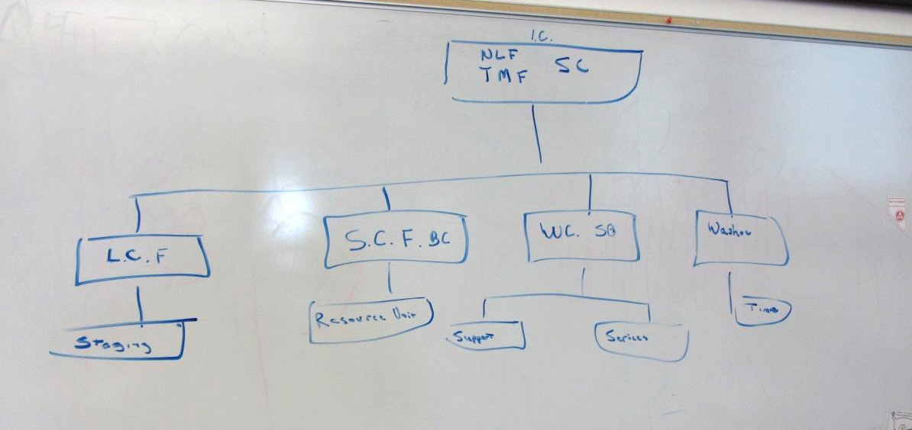
Caption: Objective 1 was explored by having the TTX participants assist in the development of the response organization chart (ICS207).
- Incident Command: North Lyon County, Storey County and Truckee Meadows would get the call from dispatch and be the first on-scene.
  - North Lyon County Fire could set up the staging area.
  - Storey County Fire Battalion Chief: could be set up as the resource unit
  - Washoe County Sheriff’s Office could be set up as support and services branches
  - Washoe County would be on-scene due to their close proximity to the incident.

State Patrol should be on-scene but since there is a fire, the Fire Chief would be the IC until the response progressed and a Unified Command was created. Firefighting efforts need to be cognizant of the proximity of the Truckee River and determine which firefighting materials are best utilized in suppressing the fire without increasing the spread of contaminated runoff. Information in the Truckee River Geographic Response Plan should be utilized to ensure that all the correct notifications have been made and measures have been taken to minimize the impacts into the Truckee River.

Other agencies that would be notified are:
- Pyramid Tribe
- North Lyon County Emergency Management
- Quad County
- District Attorney

Nevada Highway Patrol (NHP) would be making their own notifications for support including the Truckee Criminal Investigative Division (Bureau of Reclamation), obtaining extra foam for the firefighting trucks, and notifying the 10-15 neighboring homes that could be impacted by this accident. NHP would also be notifying the animal response teams and the National Transportation Safety Board (NTSB). Although the railroad would not be the responsible party in this accident, they would still notify their dispatch which would in turn notify all the federal, state and local agencies associated with the response jurisdiction. Storey County would notify the Nevada Department of Agriculture who would notify and coordinate with all the animal support agencies.

Generally speaking, the IC organization chart developed during the exercise accurately assigned the appropriate roles to the appropriate agencies.
RECOMMENDATIONS
- Make sure that all response agencies have their notification information correct and up-to-date.
- Conduct annual communications drill of the notification process.
- Conduct an exercise or training with more of the first responders and the railroads, to identify any response gaps not addressed.

OBJECTIVE 2 – PREPARE INCIDENT OBJECTIVES AND NOTIFICATION LIST

The following section describes observations and recommendations related to the following exercise objective:
“Prepare an Incident Objectives (ICS 202) and an Incident Notification list/flowchart (during both normal business and after business hours).”

OBSERVATIONS
First responders from Storey County and North Lyon County continued to support the TTX by documenting the discussion of the flow of the response.
Objective 2 was developed by the TTX participants discussing the priorities of the response and identified agencies and their roles and responsibilities for the response.
Exercise participants identified the top five priorities with this incident.
- Fire and Life Saving
  - Medical response
  - Fire suppression
  - Control the spread of the fire and contamination
  - Obtaining lighting for the night rescue operations
- Transportation coordination
  - Nevada Department of Transportation
  - Interstate 80
  - Trains
- Animal Rescue/Disposal
  - Animal containment
  - Wildlife service notification
  - Washoe County Animal Control
- HAZMAT
  - USEPA
  - Use booms or earthen dams to stop the flow of oil into the Truckee River
- Contaminated Animals
  - Decontamination
  - Segregation of live and dead livestock
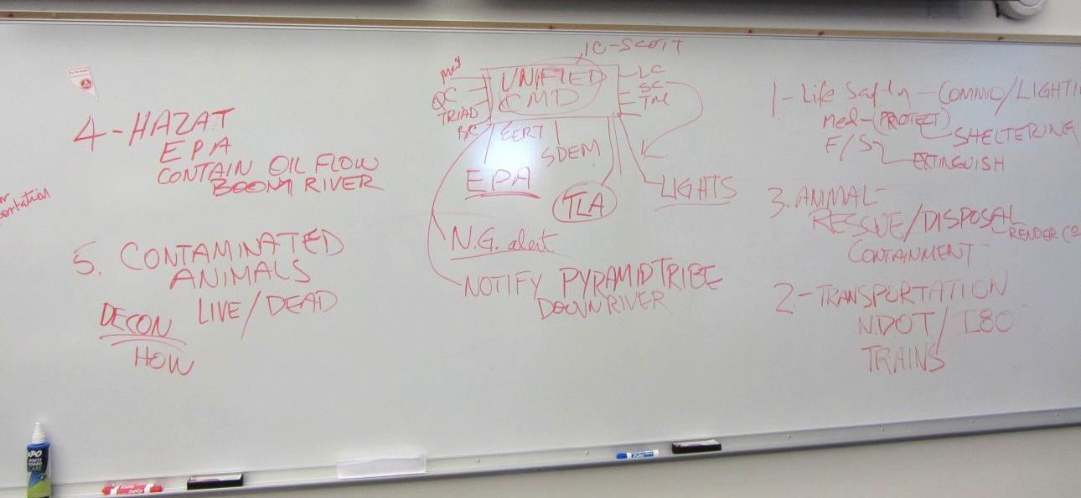
Caption: Incident objectives/priorities identified during the TTX.
RECOMMENDATIONS
- Conduct additional training around the roles and responsibilities of the local emergency response and animal control personnel. Practice the principles of Unified Command and Multi-Agency Coordination.
- Conduct additional training around the roles and responsibilities of the local emergency response and veterinary personnel. Develop a response plan that combines the expertise of both communities thereby eliminating the division or separation of response efforts. One community, one response.

OBJECTIVE 3 – IDENTIFY RESPONSE AND TRANSPORTATION RESOURCES AND PROTOCOLS FOR ANIMAL RESPONSE ACTIVITIES
The following section describes observations and recommendations related to the following exercise objective:
“Identify response and transportation resources and protocols for animal response activities (e.g., Livestock Response Task Force Team deployment, etc.) consistent with draft State Animal/Ag Response Plan).”
OBSERVATIONS
Overall the veterinary community felt that the emphasis was too heavily biased toward the fire/hazmat response and not the animals. Although the majority of the exercise attendees were of the agriculture-animal community, the key players participating in the exercise discussions were the first responders. The draft State Animal/Agriculture Response Plan was not addressed. The veterinary community did not know how to approach the decontamination of the livestock and the first responders did not consider the livestock a priority. However, other veterinarians mentioned that they have tried to respond to this type of incident, only to be turned away by the Highway patrol
One participant noted that the primary response team should employ a practicing large animal veterinarian to assess the status of the livestock that need to be treated or euthanized. Veterinarians have the final authority on the disposition of the livestock.
RECOMMENDATIONS

- Conduct additional tabletop exercises to further explore the response and recovery actions expected by local, state, and federal response and veterinary partners with respect to animal response activities.
- Transportation coordination is of the utmost of importance but each of the response communities defines it differently. More planning to determine solutions that work for the entire community.
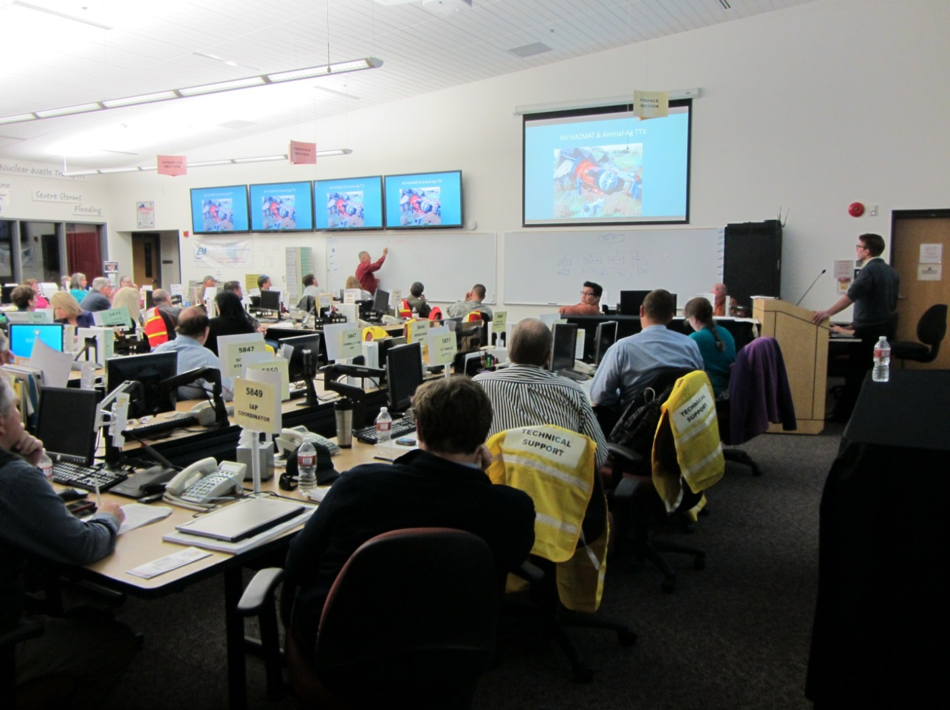
Caption: Joe Curtis, Storey County Emergency Management lead the Unified Command discussion for Module 2.

OBJECTIVE 4 – IDENTIFY THE RESPONSIBLE PARTIES INVOLVED WITH DECONTAMINATION/DISPOSAL OF CARCASSES AND OBJECTIVE 5 – IDENTIFY AND DEVELOP A STRATEGY TO ADDRESS CONTAMINATION RISK TO OTHER LIVESTOCK/ANIMALS NOT DIRECTLY IMPACTED BY THE INCIDENT
The following section describes observations and recommendations related to the following exercise objectives:
“Identify the responsible agency (s), contractor support, approved disposal methods, and approved sites for decontamination and disposal of carcasses consistent with new EPA/USCG/USDA MOU [Wildlife Response Activities during Oil or Hazardous Substance Pollution Incidents].”
and
“Identify and develop a strategy to address contamination risk to other livestock/animals not directly impacted by incidents (e.g., surrounding ranches, feedlot, wildlife, etc.).”
OBSERVATIONS
Discussions are focused on the animal-ag community and not the first responders. At 72 hours into the response, the fire would be out and the first responders will have demobilized. The Unified Command would include the following agencies/organizations:
- United States Department of Agriculture/Animal Plant Health Inspection Service
- Nevada Department of Agriculture
- United States Fish and Wildlife Services
- USEPA
- Wildlife Subject Matter Experts to identify threatened or endangered species
- Reno Rendering
Response objectives at 72 hours would include:
- Contain downstream contaminants
- Protect drinking water sources
- Complete SCAT shoreline cleanup objectives
- Arrange transportation for livestock
- Endangered and non-endangered species assessment
- Decontaminate and the disposition of all the affected animals
- Cultural considerations depending on where the contamination spreads
- Health and Safety of the Responders
The animals would be decontaminated on-site and the contaminated water will be disposed of properly. At Reno Rendering the transportation trucks are sealed therefore no contamination would spill into the other compartments on the truck or out of the truck onto the pavement. Costs for the cleanup action would exceed the State’s budget and they would call for assistance from their Federal partners. Another potential resource would be the National Veterinary Stockpile (NVS). The NVS resources can be deployed at the request from the State Veterinarian to APHIS/VS. . The accident was not the result of a natural disaster or act of terrorism and has a Potentially Responsible Party (PRP) for the incident, therefore it would not qualify as a Presidentially-Declared Disaster event under the Robert T. Stafford Act.
RECOMMENDATIONS

- Conduct additional tabletop exercises to further explore the response and recovery actions expected by local, state, and federal response partners with respect to the roles and responsibilities of the animal-agricultural community.
- Conduct trainings for the local, state, federal, veterinary partners that include their contractors with regards to the decontamination and disposal of carcasses.
- Plan additional tabletop exercises to develop strategies addressing the risk of spreading contamination to other livestock/animals not involved in the incident.

CONCLUSION
The Nevada HAZMAT & Animal-Agriculture (Contaminated Livestock) Discussion-Based Tabletop Exercise provided an opportunity for local, state, federal stakeholders and the veterinary community located in the response corridor between Sparks and Fernley, Nevada, to explore the coordination, lines of authority and communication required to manage an off-highway train vs. truck incident that involves hazardous materials and livestock.. It was determined that all objectives were met or will be addressed through actions identified in an Improvement Plan that provides guidance for the community and the stakeholders to continue to enhance response/recovery coordination and capabilities.

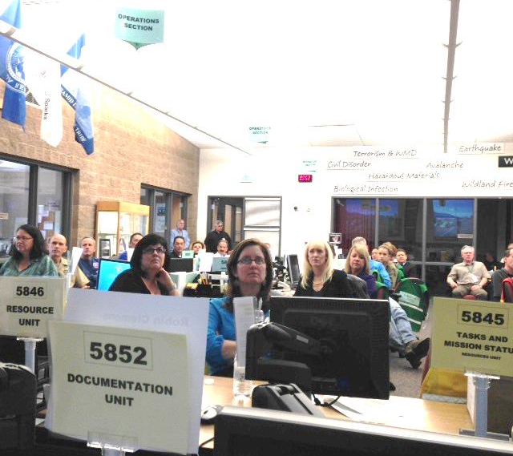
Caption: The exercise was attended by a wide range of stakeholders (both public and private) at the local, state, and federal level.

THIS PAGE LEFT BLANK INTENTIONALLY

ATTACHMENT A LIST OF ACRONYMS

AAR/IP After Action Report/Improvement Plan
APHIS Animal Plant Health Inspection Service
CalOES California Office of Emergency Services
DOI-BLM Department of the Interior- Bureau of Land Management
DOI-BOR Department of the Interior- Bureau of Reclamation
EM Emergency Management
EOC Emergency Operation Center
FEMA Federal Emergency Management Agency
FOSC Federal On-Scene Coordinator
HAZMAT Hazardous Materials
HSEEP Homeland Security Exercise Evaluation Program
ICS Incident Command System
MOU Memorandum of Understanding
NVS National Veterinary Stockpile
NDA Nevada Department of Agriculture
NDEM Nevada Division of Environmental Management
NIMS National Incident Management System
NNG Nevada National Guard
NOAA National Oceanic and Atmospheric Administration
NRC National Response Center
OSRO Oil Spill Response Organization
PRP Potentially Responsible party
RRT Regional Response Team
SCAT Shoreline Cleanup and Assessment Technique
SFC Sargent First Class
SitMan Situation Manual
SMEs Subject Matter Experts
TTX Tabletop Exercise
US EPA United States Environmental Protection Agency
US EPA-ERT United States Environmental Protection Agency –Environmental Response Team
USCG United States Coast Guard
USDA/FS United States Department of Agriculture, Forest Service

USDA/APHIS/MRPBS ESF 11 United States Department of Agriculture/ Animal Plant Health Inspection Service/Marketing & Regulatory Programs Business Services - Emergency Support Function 11

USDA/APHIS United States Department of Agriculture/ Animal Plant Health Inspection Service
USDA/APHIS/IES United States Department of Agriculture/ Animal Plant Health Inspection Service/Investigative Enforcement Services

USDA/APHIS/WS United States Department of Agriculture/ Animal Plant Health Inspection Service/Wildlife Service

USDA/FSIS/OIEA/CID United States Department of Agriculture/ Food Safety and Inspection Service/Office of Investigation, Enforcement and Audit/Compliance and Investigation Division

USDA/VS United States Department of Agriculture/Veterinary Service

ATTACHMENT B EXERCISE FEEDBACK SUMMARY
Nevada Hazmat Animal -Agriculture (Contaminated Livestock) Discussion-Based Tabletop Exercise Feedback Summary Table
Total Respondents: 15
 | Strongly Agree | Agree | Neutral | Disagree | Strongly Disagree
The exercise met my expectations | 8 | 7 | 0 | 0 | 0
I will be able to apply the knowledge learned | 6 | 8 | 1 | 0 | 0
The exercise objectives for each topic were identified and followed | 6 | 9 | 0 | 0 | 0
The content was organized and easy to follow. | 8 | 7 | 0 | 0 | 0
The materials distributed were pertinent and useful. | 8 | 7 | 0 | 0 | 0
The facilitators were knowledgeable. | 8 | 7 | 0 | 0 | 0
The quality of instruction was good. | 6 | 9 | 0 | 0 | 0
Participation and interaction were encouraged. | 10 | 5 | 0 | 0 | 0
Adequate time was provided for questions and discussion. | 12 | 3 | 0 | 0 | 0
 | Excellent | Good | Average | Poor | Very Poor
How would you rate the exercise overall? | 10 | 5 | 0 | 0 | 0

Question | Percent of Respondents Who Answered Agree or Strongly Agree
The exercise met my expectations | 100%
I will be able to apply the knowledge learned | 87%
The exercise objectives for each topic were identified and followed | 100%
The content was organized and easy to follow. | 100%
The materials distributed were pertinent and useful. | 100%
The facilitators were knowledgeable. | 100%
The quality of instruction was good. | 100%
Participation and interaction were encouraged. | 100%
Adequate time was provided for questions and discussion. | 100%

THIS PAGE LEFT BLANK INTENTIONALLY

ATTACHMENT C IMPROVEMENT PLAN
Objective | Recommendation | Priority | Program Element | Responsible Party | Timeframe
Exercise Design | Include more agencies and stakeholders in future exercises. | Medium | Exercise | RRTIX/Exercise Design Team | Aspirational
Exercise Design | Conduct annual exercises to introduce and test the TRGRP. | Medium | Exercise | All | 1 - 2 years
1 – Incident Command System Response Organization | Conduct additional training around principles of Incident and Unified Command with Multi-Agency Coordination. | Medium | Training | State Emergency Management agencies/Local Response Partners | < 1 year
1 – Incident Command System Response Organization | Provide training to clarify the role and lines of authority for the local, state and federal agencies with the animal/agricultural-veterinary response capabilities and resources in supporting response efforts. | High | Training | State Emergency Management agencies/Local Response Partners | Aspirational
2- Prepare Incident Objectives Notification Lists | Conduct additional exercises regarding the roles, responsibilities including jurisdictional authorities for the response and veterinary communities. | Medium | Exercise | State /Local and Veterinary Response Authorities | Aspirational
2- Prepare Incident Objectives Notification Lists | Conduct additional training on Unified Command and multi- agency coordination. | High | Training | State /Local and Veterinary Response Authorities | Aspirational
3 – Identify Response and Transportation Resources and Protocols | Conduct tabletop exercises on Unified Command, transportation resources and include protocols for animal response activities. | Medium | Exercise | All | < 1 year
3 – Identify Response and Transportation Resources and Protocols | Conduct training around the roles and responsibilities of the local, state emergency response and veterinary personnel. | Medium | Training | State /Local and Veterinary Response Authorities | Aspirational
4– Identify the Responsible agencies, contractor support, approved disposal methods. | Conduct additional exercises to further explore the response, recovery actions and disposal practiced disposal methods expected by local, state, federal and veterinary response partners. | Medium | Exercise | State /Local and Veterinary Response Authorities | Aspirational
4– Identify the Responsible agencies, contractor support, approved disposal methods. | Conduct trainings/discussions to explore the response and recovery actions expected by local, state, federal, veterinary response partners including their contractor support. | Medium | Training | State /Local and Veterinary Response Authorities | Aspirational
5 – Identify and Develop a Strategy to address contamination risks to other livestock/animals not directly impacted by the incident. | Conduct additional training – planning discussions to develop strategies addressing the risk of spreading contamination to other livestock/animals during or after a hazmat incident. | Medium | Training | All | Aspirational
5 – Identify and Develop a Strategy to address contamination risks to other livestock/animals not directly impacted by the incident. | Conduct an exercise on the strategies to minimize the risk of spreading contamination to other livestock/ animals during or after a hazmat incident. | Medium | Exercise | All | Aspirational
5 – Identify and Develop a Strategy to address contamination risks to other livestock/animals not directly impacted by the incident. | Develop an MOU for the Livestock Task Force. | Medium | Organization | State Ag and NG | Aspirational

